**Template for a Doctoral Colloquium Paper**

**Paper Title (Cover Page)**

**……………………………………………………………………………………………**

**………………………………………………………………………****…………****…………**

Name-Surname of Doctoral Student (First Author)

Studying University, Country

Course/Program

Email address and telephone number

Name-Surname of Thesis Supervisor(s)

Affiliated University, Country

Email address

Date

**ABSTRACT:** The abstract needs to provide a brief but comprehensive summary of the contents of your paper. It provides an overview of the paper and helps readers decide whether to read the full text. Visit and read [Abstract and Keywords Guide, APA Style 7th Edition](https://apastyle.apa.org/instructional-aids/abstract-keywords-guide.pdf).

(**200-300 words**)

**ABSTRACT:** ……………………………………………………………………………

……………………………………………………………………………………………

……………………………………………………………………………………………

……………………………………………………………………………………………

***Keywords:*** *aging, attention, information processing, emotion, Japan*

(***5 keywords*,** lowercased (but capitalize proper nouns), *italic* (but not bold)

Keywords must be descriptive and capture the most important aspects of your paper. They are used for indexing in databases and as search terms for readers. Visit and read [Abstract and Keywords Guide, APA Style 7th Edition](https://apastyle.apa.org/instructional-aids/abstract-keywords-guide.pdf).

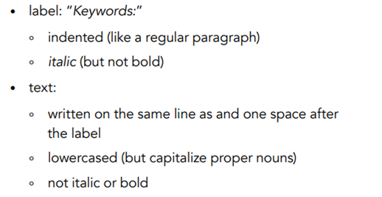

**About the main body** (Overall text length should be about **4,000- 8,000 words**.)

Illustrated beloware the four heading levels used in the conference papers. All text paragraphs should be **single-spaced**, with the first line intended by 10 mm. No spaces should be placed between paragraphs. Double spacing should only be used before and after Level 1 and Level 2 headings as shown in this example. The position and style of headings should follow the example below.

Please use **Times New Roman font** with **Font size 12**, and **page size A4.**

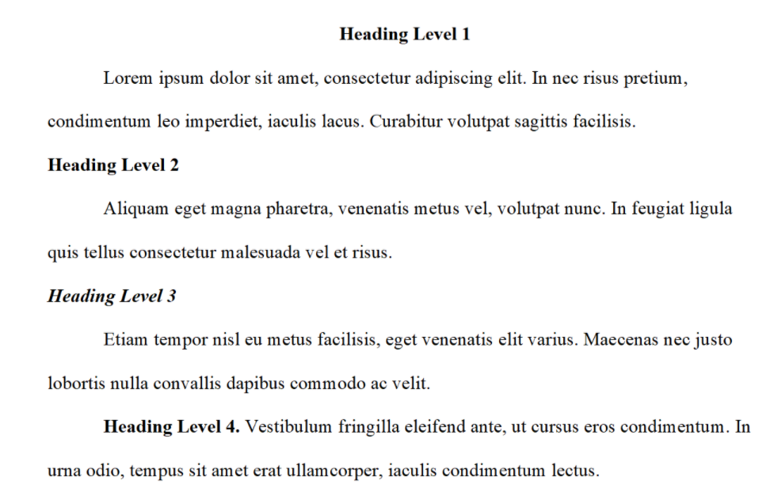

**1. INTRODUCTION**

(Background information and an overview of related work in the doctoral work; the problem domain; the specific problem addressed; research questions; and research objectives.)

xxx……………………………………………………………………………………

……………………………………………………………………………………………

……………………………………………………………………………………………

**Heading Level 2**

xxx……………………………………………………………………………………

……………………………………………………………………………………………

……………………………………………………………………………………………

……………………………………………………………………………………………

……………………………………………………………………………………………

***Heading Level 3***

xxx……………………………………………………………………………………

……………………………………………………………………………………………

……………………………………………………………………………………………

……………………………………………………………………………………………

……………………………………………………………………………………………

**2. LITERATURE REVIEW AND HYPOTHESIS (HYPOTHESES) DEVELOPMENT**

**(**The original fundamental concepts; related literature; hypothesis/proposition of the thesis; conceptual framework of the study.)

xxx……………………………………………………………………………………

……………………………………………………………………………………………

……………………………………………………………………………………………

**Heading Level 2**

xxx……………………………………………………………………………………

……………………………………………………………………………………………

……………………………………………………………………………………………

……………………………………………………………………………………………

……………………………………………………………………………………………

***Heading Level 3***

xxx……………………………………………………………………………………

……………………………………………………………………………………………

……………………………………………………………………………………………

……………………………………………………………………………………………

……………………………………………………………………………………………

**3. METHOD(S)**

(Methodological approach, e.g., population, sample, measurements, data collection method, and data analysis.)

xxx……………………………………………………………………………………

……………………………………………………………………………………………

……………………………………………………………………………………………

**Heading Level 2**

xxx……………………………………………………………………………………

……………………………………………………………………………………………

……………………………………………………………………………………………

……………………………………………………………………………………………

……………………………………………………………………………………………

Figure 1: (If any)

Table 1: (if any)

[Sample Annotated Professional Paper in APA Style](https://apastyle.apa.org/style-grammar-guidelines/paper-format/professional-annotated.pdf)

***Heading Level 3***

xxx……………………………………………………………………………………

……………………………………………………………………………………………

**4. FINDINGS AND DISCUSSION**

(Results; discussion with previous studies.)

xxx……………………………………………………………………………………

……………………………………………………………………………………………

……………………………………………………………………………………………

**Heading Level 2**

xxx……………………………………………………………………………………

……………………………………………………………………………………………

……………………………………………………………………………………………

……………………………………………………………………………………………

……………………………………………………………………………………………

***Heading Level 3***

xxx……………………………………………………………………………………

……………………………………………………………………………………………

……………………………………………………………………………………………

……………………………………………………………………………………………

……………………………………………………………………………………………

**5. CONCLUSION(S)**

**(**Conclusion; expected contributions; recommendation; future studies; the research progress.)

xxx……………………………………………………………………………………

……………………………………………………………………………………………

……………………………………………………………………………………………

……………………………………………………………………………………………

**REFERENCES**

(Follow acceptable citation styles, American Psychological Association or [APA Style](https://apastyle.apa.org/), **but use a Single Space**).

References are ordered alphabetically by the first author's last name. If the author is unknown, order the reference entry by the first meaningful word of the title (ignoring articles: "the," "a," or "an").

