**Template for an Academic Paper**

**The Margin on an A4 page**

APMAA adopts the margins predefined by Microsoft Word. Authors can **choose either Normal margins or Moderate margins.**

| **Word: Normal** | Top 35.01 mm, Bottom 30 mm, Left 30 mm, Right 30mm |
| --- | --- |
| **Word: Moderate** | Top mm 25.4, Bottom 25.4 mm, Left 19.05 mm, Right 19.05 mm |

**Cover Page**

**Paper Title**

**……………………………………………………………………………**

**……………………………………………………………………………**

The author's name (First name, initial(s), and family name)

Position and affiliation

Affiliated University

Email address

The corresponding author's name (First name, initial(s), and family name)

Position and affiliation

Affiliated University

Email address and telephone number

**Text**

**Paper Title**

(14-point fonts; capitalize the first character of each word)

**ABSTRACT:** The abstract needs to provide a brief but comprehensive summary of the contents of your paper. It provides an overview of the paper and helps readers decide whether to read the full text. Visit and read [Abstract and Keywords Guide, APA Style 7th Edition](https://apastyle.apa.org/instructional-aids/abstract-keywords-guide.pdf).

(**200-300 words**)

**ABSTRACT:** ……………………………………………………………………………

……………………………………………………………………………………………

……………………………………………………………………………………………

……………………………………………………………………………………………

……………………………………………………………………………………………

……………………………………………………………………………………………

……………………………………………………………………………………………

……………………………………………………………………………………………

***Keywords:*** *aging, attention, information processing, emotion, Japan*

(***5 keywords*,** lowercased (but capitalize proper nouns), *italic* (but not bold)

Keywords must be descriptive and capture the most important aspects of your paper. They are used for indexing in databases and as search terms for readers. Visit and read [Abstract and Keywords Guide, APA Style 7th Edition](https://apastyle.apa.org/instructional-aids/abstract-keywords-guide.pdf).

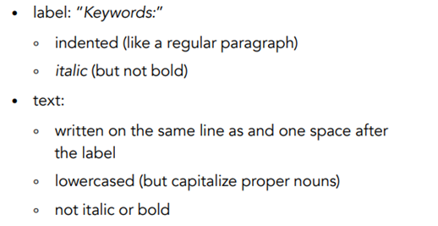

**About the main body**

(The text length should be **over 5,000 but usually not exceed 10,000 words)**

Illustrated beloware the four heading levels used in the conference papers. All text paragraphs should be **single-spaced**, with the first line intended to be 10 mm. No spaces should be placed between paragraphs. Double spacing should only be used before and after Level 1 and Level 2 headings, as shown in this example. The position and style of headings should follow the example below. Please use **Times New Roman font** with **12 font** and **page size A4.**

| **HEADING LEVEL 1**  **Heading Level 2**  ***Heading Level 3***  **Heading Level 4.** |
| --- |

**1. INTRODUCTION**

(Background of the study and an overview of related work in the area of the research; the problem domain; the specific problem addressed; research questions, research objectives, and expected research outcome.)

xxx……………………………………………………………………………………

……………………………………………………………………………………………

……………………………………………………………………………………………

……………………………………………………………………………………………

xxx……………………………………………………………………………………

……………………………………………………………………………………………

……………………………………………………………………………………………

……………………………………………………………………………………………

……………………………………………………………………………………………

**2. LITERATURE REVIEW AND HYPOTHESIS (HYPOTHESES)**

**DEVELOPMENT**

**(**The original fundamental concepts; related literature; hypothesis/proposition of the thesis; conceptual framework of the study.)

xxx……………………………………………………………………………………

……………………………………………………………………………………………

**Heading Level 2**

xxx……………………………………………………………………………………

……………………………………………………………………………………………

……………………………………………………………………………………………

……………………………………………………………………………………………

***Heading Level 3***

xxx……………………………………………………………………………………

…………………………………………………………………………………………………………………………………………………………………………………………

……………………………………………………………………………………………

**3. METHOD(S)**

**(**Methodological approach, e.g., population, sample, measurements, data collection method, and data analysis.)

xxx…………………………………………………………………………………………………………………………………………………………………………………

**Heading Level 2**

xxx…………………………………………………………………………………………………………………………………………………………………………………

……………………………………………………………………………………………

……………………………………………………………………………………………

Figure 1: (If any)

Table 1: (if any)

[Sample Annotated Professional Paper in APA Style](https://apastyle.apa.org/style-grammar-guidelines/paper-format/professional-annotated.pdf)

***Heading Level 3***

xxx……………………………………………………………………………………

……………………………………………………………………………………………

……………………………………………………………………………………………

……………………………………………………………………………………………

**Heading Level 4**

xxx……………………………………………………………………………………

……………………………………………………………………………………………

……………………………………………………………………………………………

……………………………………………………………………………………………

**4. FINDINGS AND DISCUSSION**

(Results; discussion with previous studies.)

xxx…………………………………………………………………………………………………………………………………………………………………………………

……………………………………………………………………………………………

**Heading Level 2**

xxx…………………………………………………………………………………………………………………………………………………………………………………

……………………………………………………………………………………………

……………………………………………………………………………………………

***Heading Level 3*** xxx……………………………………………………………………………………

……………………………………………………………………………………………

……………………………………………………………………………………………

**5. CONCLUSION(S)**

**(**Conclusion; expected contributions; recommendation; future studies; the research progress.)

xxx……………………………………………………………………………………

……………………………………………………………………………………………

……………………………………………………………………………………………

……………………………………………………………………………………………

**REFERENCES**

References are ordered alphabetically by the first author's last name. If the author is unknown, order the reference entry by the first meaningful word of the title (ignoring articles: "the," "a," or "an").

(Follow acceptable citation styles, American Psychological Association or [APA Style](https://apastyle.apa.org/). The following example uses double-spaced lines; however, for APMAA 2024, you need to use **single-spaced lines**)

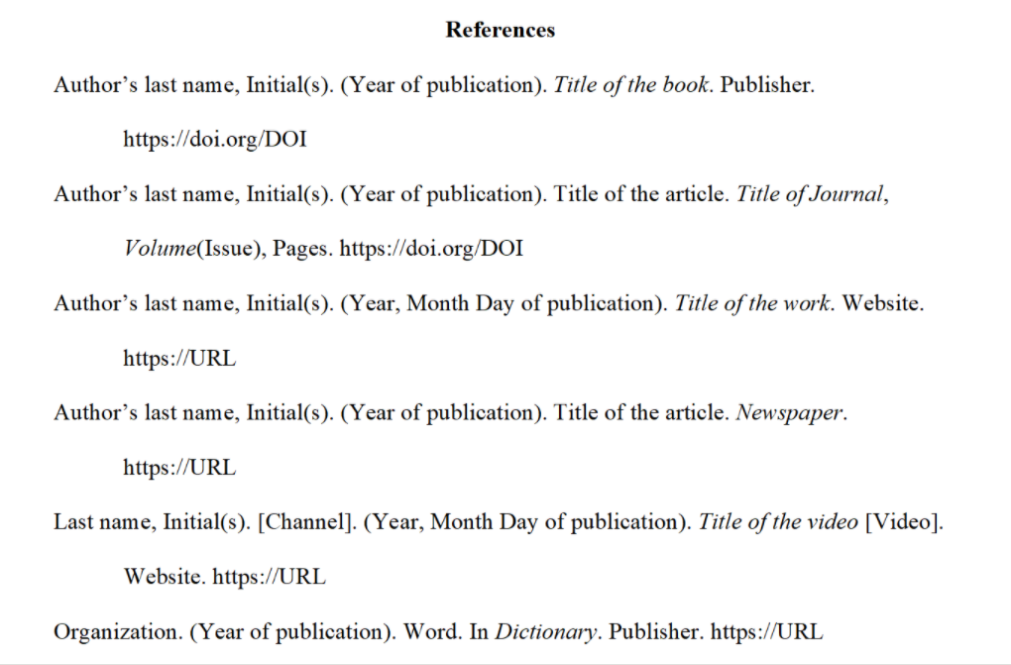

……………………………………………………………………………………………

……………………………………………………………………………………………

……………………………………………………………………………………………

| **How do you submit your documents to the CMT?**  APMAA 2024 employs the Conference Management Toolkit (CMT) that Microsoft Corporation provides to manage submitted papers.  CMT→ Author console →+Create New submission (select the **Academic Paper Sessions track**) →Edit "Create New Submission" page  MS-CMT Structure of the APMAA2024  (Track 1) Academic Paper Sessions → Primary subject areas (14) → Secondary subject areas  (Track 2) **Doctoral Colloquium Sessions** (Research papers)  (Track 3) Other (for speakers of Plenary sessions, Forums, and Doctoral seminar )  (Track 4) Organizers' Practice (Soley for the use of the Organizer)  We will open the CMT submission site on May 1, 2024. The Paper Submission Deadline is July 15. |
| --- |

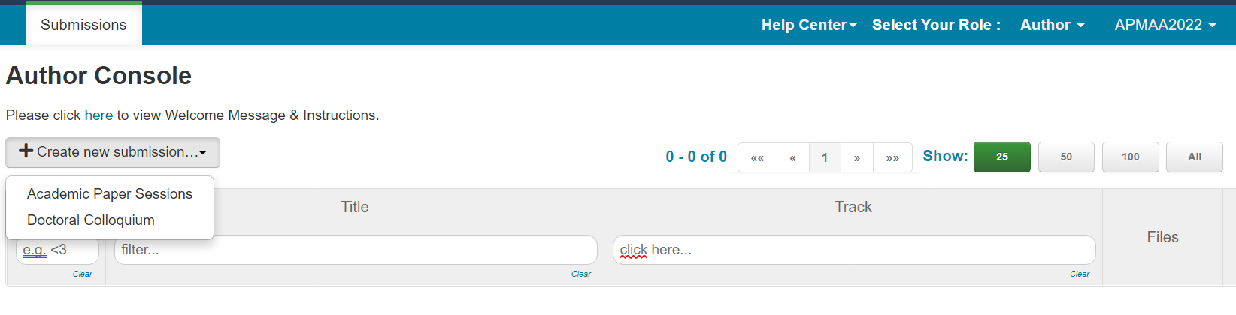

**The *Publication Manual*** offers guidance on choosing the headings, tables, figures, language, and tone that will result in powerful, concise, and elegant scholarly communication.

[Publication Manual of the American Psychological Association, Seventh Edition (2020) (apa.org)](https://apastyle.apa.org/products/publication-manual-7th-edition)

[Research Paper Format | APA, MLA, & Chicago Templates (scribbr.com)](https://www.scribbr.com/research-paper/research-paper-format/)

[**Sample Annotated Student Paper in APA Style**](https://apastyle.apa.org/style-grammar-guidelines/paper-format/student-annotated.pdf)

The following two sample papers were published in annotated format in the *Publication Manual* and are reproduced here for your ease of reference. The annotations draw attention to relevant content and formatting and provide users with the relevant sections of the *Publication Manual* (7th ed.) to consult for more information.

* [Annotated student sample paper (PDF, 2MB)](https://apastyle.apa.org/style-grammar-guidelines/paper-format/student-annotated.pdf)
* [Annotated professional sample paper (PDF, 3MB)](https://apastyle.apa.org/style-grammar-guidelines/paper-format/professional-annotated.pdf)

Also, URLs below offer sample papers in Microsoft Word (.docx) file format without the annotations.

* [Student sample paper (DOCX, 36KB)](https://apastyle.apa.org/style-grammar-guidelines/paper-format/student-paper.docx)
* [Professional sample paper (DOCX, 96KB)](https://apastyle.apa.org/style-grammar-guidelines/paper-format/professional-paper.docx)

**The single or double space between sentences** argument has been ongoing for decades. Traditional, pre-digital typesetting required the use of double-spacing after periods and colons. This was largely due to the limitations of now-antiquated technology and was the standard style taught by most schools until around 20 years ago. With the advent of digital printing, the need for double spaces isn't really a thing, anymore. But a lot of people still adhere to the practice. Even style guides don't universally agree. The latest editions of the [Chicago Manual of Style](http://www.chicagomanualofstyle.org/qanda/data/faq/topics/OneSpaceorTwo/faq0001.html) and [MLA](https://style.mla.org/number-of-spaces-after-period/) both suggest a single space. The [APA guidelines](https://owl.english.purdue.edu/owl/resource/560/24/) currently suggest two spaces, but even they have gone back and forth over the years.